**sIntroduction**

For this assessment, I will be writing a report investigating the technologies used while creating computer games. However, I will be also discussing about the social trends that computer gaming has created and the technology used in the industry.

**A1 – Social trends in Computer gaming**

Video games have been around since roughly the 1950s. Initially they were created by MIT students for fun or as part of their research during their degree. This shows that the concept of gaming isn’t something that is relatively new. However, it shows that this activity was only done by those who had the knowledge to program the games themselves. Therefore, inferring the limited audience at which games were played. It was only in the late 1970s that games become more accessible to people and available in arcades and home consoles.

According to the website “Statisita”, In the USA 28% of gamers are under 18. 29% are between 18 and 35 years old. 20% are between 36 to 49 years old and 23% are 50 years old and above. However, the average of gamers in general is 35 years old. These statistics show that gaming can take place in a multitude of ways and not just the traditional sense of seating in front of a TV with a controller. Which gives me reason to believe that the adults who are playing these games are not only playing with a console but also on portable devices such as smartphones considering how they most likely have other responsibilities such as work.

<https://www.statista.com/statistics/232383/gender-split-of-us-computer-and-video-gamers/> (Put in references)

**Gender in gaming**

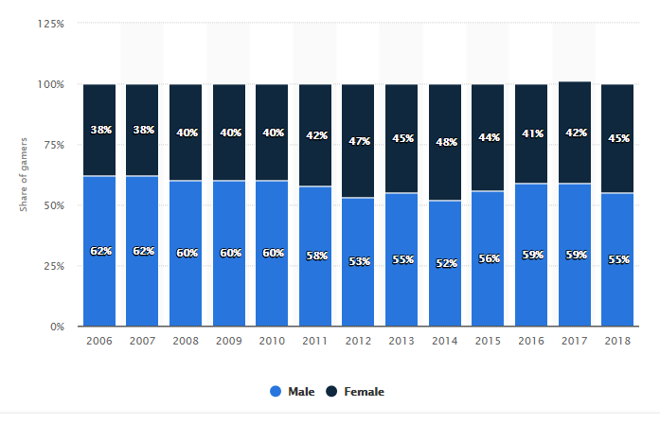While most people would generally think gaming is an activity that is only done by men, statistics show that gaming is an activity which both men and women indulge in. According to the website, Statista the ‘Distribution of computer and video gamers in the USA by gender’ shows the percentage of gender split of gamers through the years from 2006 to 2018. The trend shown in the graph below shows over the 12 years that there has been increase of 7% with the number of females playing games, with 2012 having the highest percentage of women playing over the 12 year period. This increase of players suggests that there has been an event that has brought the attention of women into playing games more than before. (Whether it be the genre, the simplicity or if the game is female friendly or not.) There are some games

**Gaming Devices**

People play games on all different platforms such as PC, smartphones, handhelds and dedicated game consoles (Xbox and PlayStation).

When consoles where first introduced in the 1970s they roughly had a price of £100. And back in the 1970s the average salary was £6,124 according to the website “Reference”. So if you worked for a month you would get about £520. Which leads me to believe that a console would only take a week to save for. However, all these consoles only had Pong as a game and if you were to alter anything you would have come from a computing background which was most unlikely.

The best-selling home console of all time is currently the PlayStation 2 which was released in March 2000 .As of January 4th, 2013 the PS2 had the largest number of units sold from launch being 158 million. With this number of units sold as of 2014 it became the best-selling console in the world. The PS2 brought to the gaming industry new ways to entertain gamers. The first thing that put it a step ahead from other consoles was the new backwards compatibility. This allowed players to play their original PlayStation games on their new PS2 but also in higher quality due to the improvements in hardware and technology. Backwards compatibility was a major selling point of the PS2 which helped people overlook the expensive price of the console when it was released.

The other example of another extremely successful console is the Nintendo DS which was the best-selling handheld of all time and the second best-selling console behind the PS2. The Nintendo DS was released in the USA on November 21st 2004. As of March 31st 2016, the DS had 154.02 million units sold. Considering it was only a handheld console, it impacted the gaming community immensely. The Nintendo DS had a dual screen (which meant games would be played using both screens), support for wireless connectivity which allowed multiple DS consoles to play in tandem over a short distance. Similarly, to the PS2, the DS had backwards compatibility with Nintendo’s predecessor handheld, the Gameboy Advance. Unlike the PS2 which had support problems with original PS games with each improved hardware, the DS was backwards compatible with all GBA games no matter whether the hardware was new or not.

Gaming home consoles can be split into generations. Currently there are 8 generations each with each mainstream company of the generation having their own each flagship console. The companies which have been the 3 major console makers of the past 3 generations are Microsoft, Sony, and Nintendo.

|  |  |  |  |
| --- | --- | --- | --- |
|  | Microsoft | Sony | Nintendo |
| 6th Generation | Xbox | PlayStation 2 | GameCube |
| 7th Generation | Xbox 360 | PlayStation 3 | Nintendo Wii |
| 8th Generation | Xbox One | PlayStation 4 | Nintendo Wii U  (Was discontinued in January 2017 due to sales) Replaced by Nintendo Switch |

**Benefits and Limitations of 8th Generation consoles**

Xbox one –

PS4

Nintendo Switch

**Types of gamers**

Gamers can be split up into 4 categories. Casual, Social, Specialist and Professional.

Casual gamers tend to be those who play games as relaxing down time. The games that Casual gamers play are those which have simple rules and don’t require much time and skill to master. Since casual gamers will not play games for a long period of time the games they play generally are short and normally can be completed in one seating.

**Examples of casual games**

Windows OS games such as Minesweeper, Solitaire

Wii Sports

Farmville

Candy Crush

Tetris

Angry Birds

Social gamers are those who play games with the intention of making friends through gaming. The games that these gamers play can be determined by what their group of friends might be into. In this category this is where multiplayer games like Call of Duty tend to be played the most due to the large groups of people who can play online with their friends or with people they don’t know.

**Examples of Social games**

Call of Duty

Fortnite

**Genres of Videogames**

Computer Games have a vast number of genres but they can separated into 6 main categories. Action, Adventure, Role-playing, Simulation, Strategy and Sports.

Action games generally focus on giving the player physical challenges for them to progress through the level. An example of a skill needed when playing these games is a good-level of hand-eye coordination and reaction time. In this genre there is a general framework which the player controls some sort of protagonist through a level collecting objects while using skills to battle against enemies.

Unlike action games which give the player physical challenges to complete, Adventure games use puzzle-solving and exploration along with an interactive story. When first introduced in the 1970s, they were not 3d games like we would imagine but in fact text-based. According to the website <https://adventure-games.wonderhowto.com/news/what-was-first-adventure-game-0131094/> The first adventure game was called “Colossal Cave Adventure” which was created for the PDP Model 10. Initially, the game had 700 lines of code in FORTRAN which was then expanded to 3000 lines of code in turn leading to 1000 lines of data.

Role-playing games are games which “players assume the roles of characters in a fictional setting”. RPGs generally have a set of guidelines/rules which help determine actions within the game. The development of the narrative is normally done by the players acting or the decisions made by them. Originally, RPGs were called table-top role-playing games which were played through discussions. Then another type of RPGs are LARPs (Live action role playing) where players perform characters actions themselves. Both types of role plays have someone who organizes and takes care of the whole event they are called GMs. They are the ones who decide the rules and setting of the event.

Simulation games try to emulate various situations in real life and change into a form of a game. These games are generally used for testing theories or analysis of data, or even predictions that people might come up with. Due to simulation games tending not to have any real objectives, the player has complete control of the characters actions. Popular types of simulation games include war, business and role play. The first simulation games were introduced in the 1980s by game company Code masters and Oliver Twins. They had released 3 sport games from 1986 to 1988 which were BMX Simulator, Grand Prix Simulator and Pro Boxing Simulator. The company were inspired by Concertmasters best-selling video games which were all based on real sports such as BMX racing and boxing.

**Game Production**

Game Production is a process which varies from who is developing the game. Game developers vary in size greatly. Indie games are those made by a single individual or the more common way, by a company which specializes in game development.

Game development companies can be split into 4 party categories. First-party developers are those who create games exclusively for their companies’ console. An example of this is when the Wii was released it came with Wii sports which was directly developed by Nintendo themselves.

Next are 2nd party developers, (this is not the official name for these companies, but it was conjured up game enthusiasts). Like FPDs, games are created exclusively for the company that they are contracted to. But, once the contract is terminated or completed they are no longer bound by the company that they were contracted by and they can continue to make games for any console that they please. A well-known example is Insomniac Games who have been contracted to make many games for the Sony consoles, but they still have a collection of games which have been made exclusively for other platforms.

Then there are 3rd party developers who create but also publish the games they create. 3rd party game developers are contracted by a publisher who will give them a contract (containing all details of what they want developed). The contract will contain milestones which have deadlines the publisher expects the developer to meet. When each milestone is completed to the proper standard and accepted by the publisher. The developers will accept a payment in royalties. Since this system allows the publisher to make sure the developers are meeting the milestones set. It has the negative effect of the developers being under constant pressure with the possibility of not getting paid. This is the reason why many 3rd Party developers don’t last very long in the game development market. An example of a 3rd party developer is Activision (First 3rd party developer) who were founded in 1979.